**Practical no. 7**

**FS19CO042**

**Aim:** Sharing files, folders and printers in a network.

**Required components:** Router, PC/Laptop

**Theory and steps:**

1. **Sharing files using basic settings**

* Open File Explorer on Windows 10.
* Navigate to the folder you want to share.
* Right-click the item, and select the Properties option.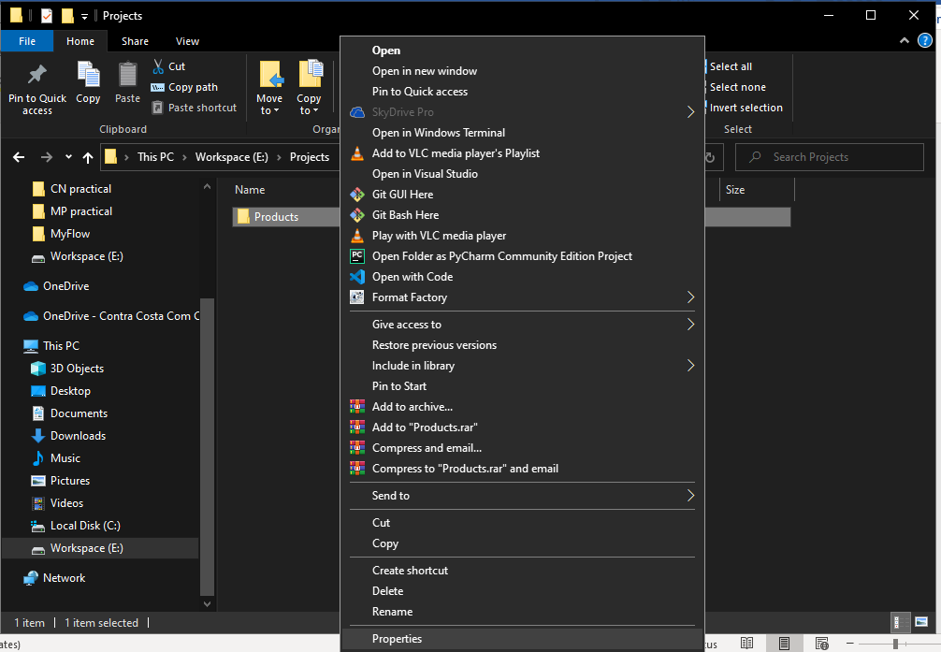
* Click on the Sharing tab.
* Click the Share button.  
  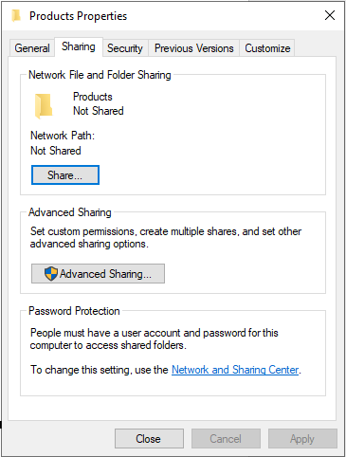
* Use the drop-down menu to select the user or group to share file or folder. (For the purpose of this guide, select the Everyone group.)
* Click the Add button.

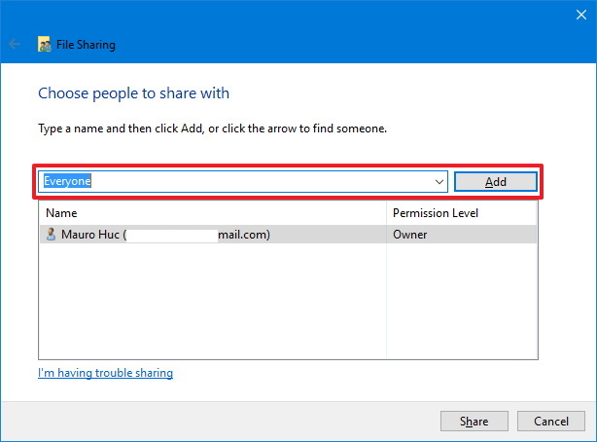

* Under the “Permission Level” section, select the type of sharing permissions you want the folder to have. For example, you can select Read (default) if you only want users to be able to view and open files. If you select Read/Write, users can view, open, modify, and delete the content on the folder you’re sharing.
* Click the Share button.

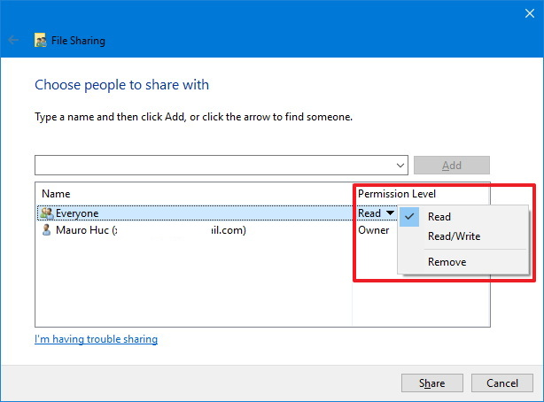

* Note the network path for the folder that other users will need to access the content over the network and click the Done button.
* Click the Close button.

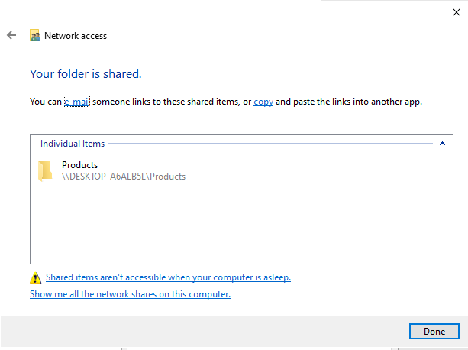

1. **Sharing files using advanced settings**

* Open File Explorer.
* Navigate to the folder you want to share.
* Right-click the item, and select the Properties option. 
* Click on the Sharing tab.
* Click the Advanced Sharing button.

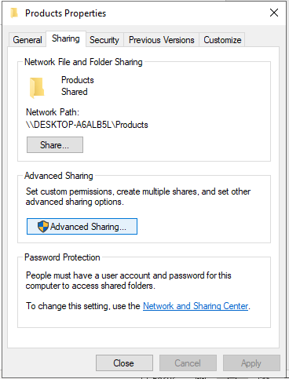

* Check the Share this folder option.
* Windows 10, by default, allows other users read-only access to the content you’re sharing, which means that they can only view files, but they cannot do anything else. If you want users to be able to edit the files, delete, and create new documents in the location, you’ll need to click the Permissions button.
* 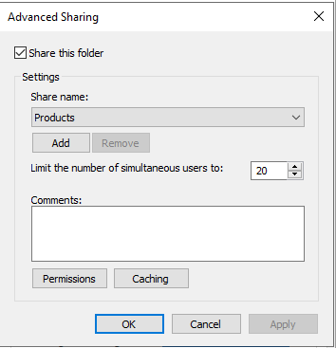
* On the Permissions window, you’ll notice the Everyone group is the default option highlighted. In the section below, you can customize the permissions for a specific user or group. If you want users to be able to open, edit, delete, and create files, then make sure to check the Read and Change permissions under Allow. Click the Apply and then OK button.

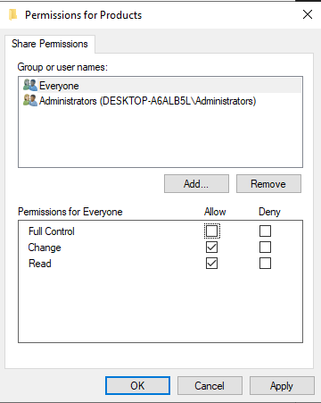

* Click the OK button again.

1. **Sharing files with a specific user**

If you only want to share files with only one specific user, you can follow the same steps, but on step 8, use these instructions:

* Select the Everyone group and click the Remove button.
* Click the Add button.

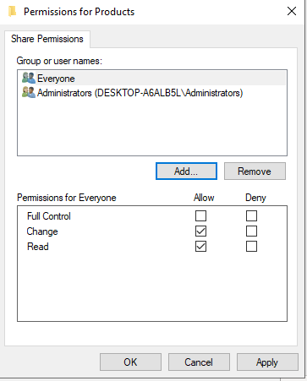

* Type the name of the user you want to share the files with.
* Click the Check Name button.
* Click the OK button.

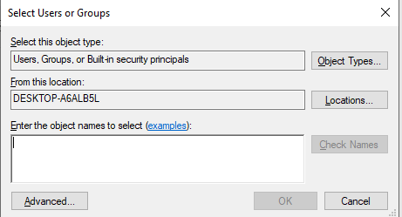

* Select the user account, and you’ll notice that the “Read” permission is checked by default. If you want the user to be able to edit, delete, and create new files, make sure to also check the Change permission option.
* Click the Apply button.
* Click the OK button.

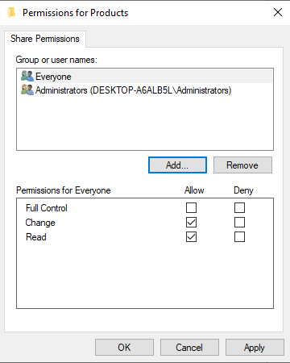

1. **How to share files over the network without needing a password**

If you’re setting up file sharing on a local network for your family members, or people you know, it’s possible to disable the requirement to sign-in with Windows credentials to allow users to access files on the sharing computer without the need of a password.

To disable password protections for file sharing on Windows 10, use these steps:

* Open Control Panel.
* Click on Network and Internet.
* Click on Network and Sharing Center.
* On the left pane, click the Change advanced sharing settings link.

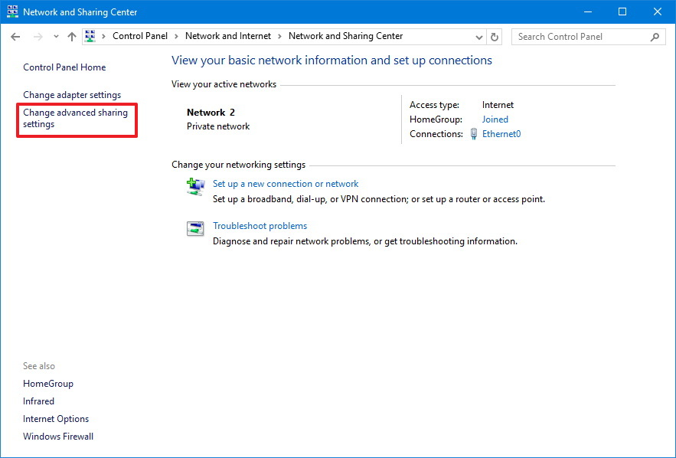

* Expand the All Networks tab.
* Under the “Password protected sharing” section, select the Turn off password protected sharing option.
* Click the Save changes button.

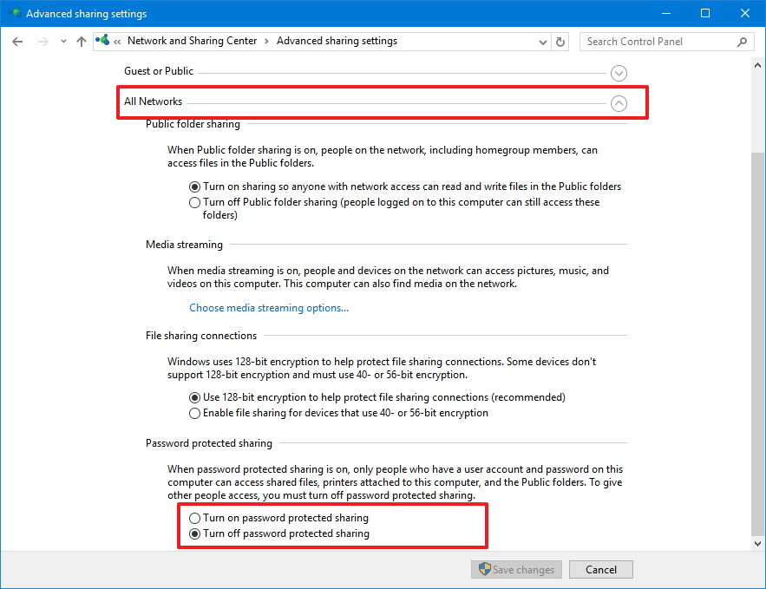

* Password protections sharing

1. **How to share files using Homegroup (deprecated)**

Typically, home users are the ones who will use Homegroup, as it offers a very easy and convenient way to share files, but this method has limited options. For example, you can share your libraries (Pictures, Videos, Music, Documents), folders, Printers and other devices connected to your PC. However, you cannot share files with versions of Windows older than Windows 7, or other devices running a different operating system, such as Android and iOS.

* Open Control Panel.
* Click on Network and Internet.
* Click on Homegroup.
* Click the Create a homegroup button.

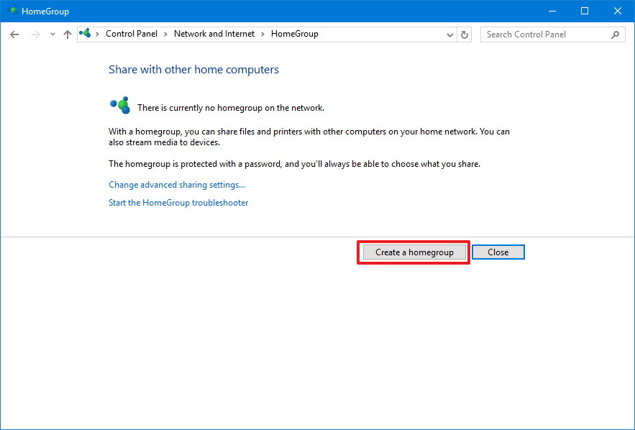

* Click the Next button.
* Use the drop-down menu to select which folders and resources (Pictures, Videos, Music, Documents, Printer & Devices) you want to share. If you don’t want to share an item, make sure to select the Not Shared option.
* Click the Next button.

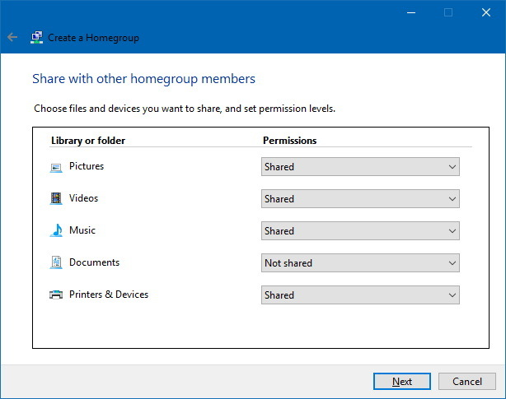

* Make sure to note the Homegroup password as you’ll need it to join other computers, and click Finish to complete the task.

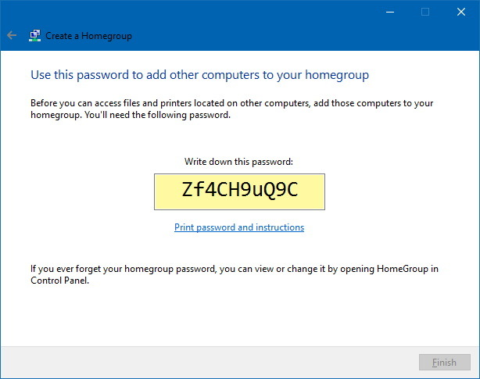

1. **Sharing files on a Homegroup**

* Open File Explorer.
* Navigate to the content you want to share.
* Right-click the folder you want to share and select the Give access to option.
* In the submenu, you’ll see a number of sharing options, including Homegroup (view) and Homegroup (view and edit).
* If you only want users to have read permissions to your files, then select the Homegroup (view) option. If you want users to have read and write permissions, which also allows them to delete and create files and folders, then select the Homegroup (view and edit) option.

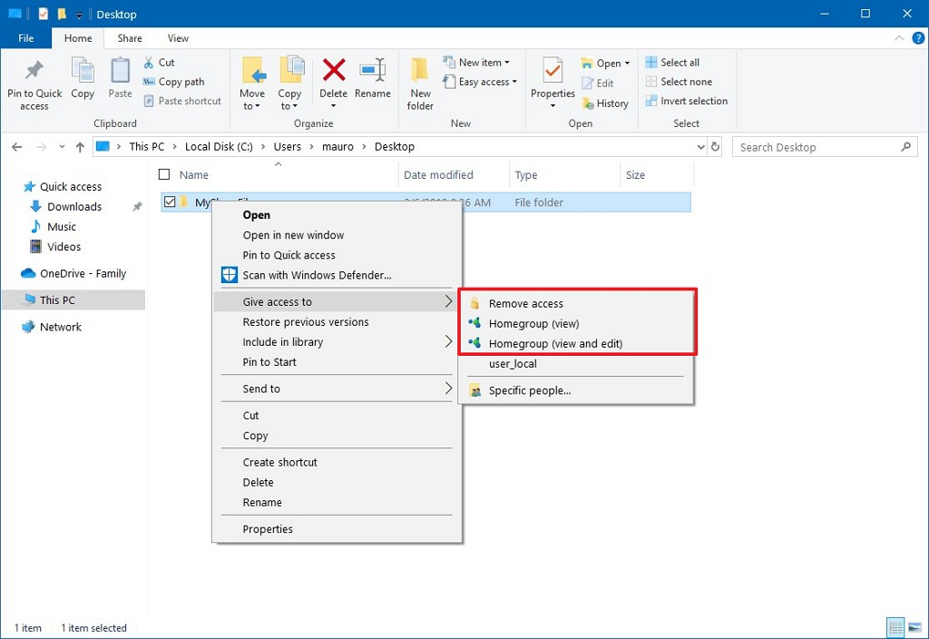

1. **How to share files using OneDrive**

* Open your OneDrive folder on Windows 10.
* Navigate to the folder you want to share.
* Right-click the folder and select the Share option.

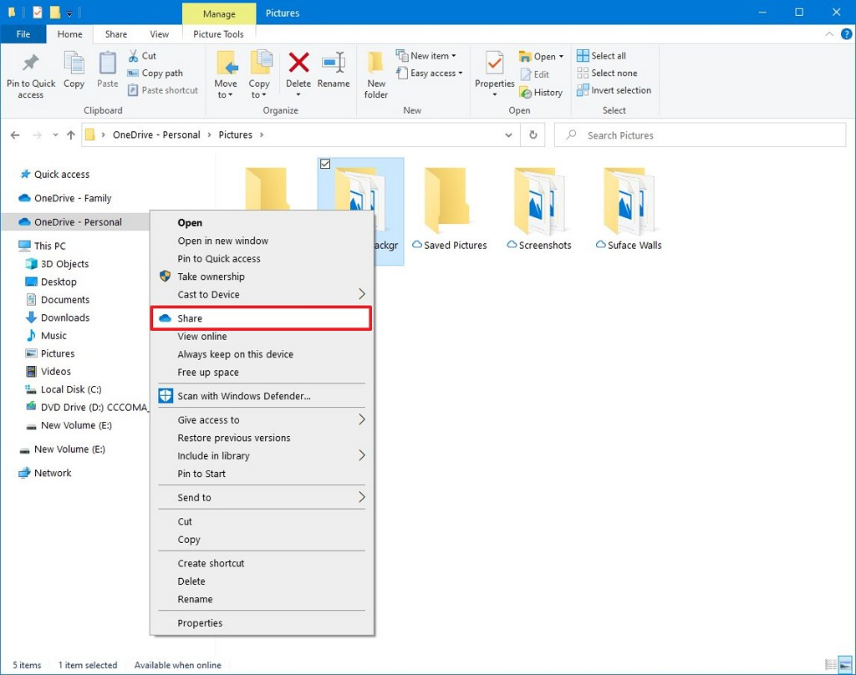

* Specify the email for the person you want to share the content. (Or the available options to copy the link or share files using other apps.)

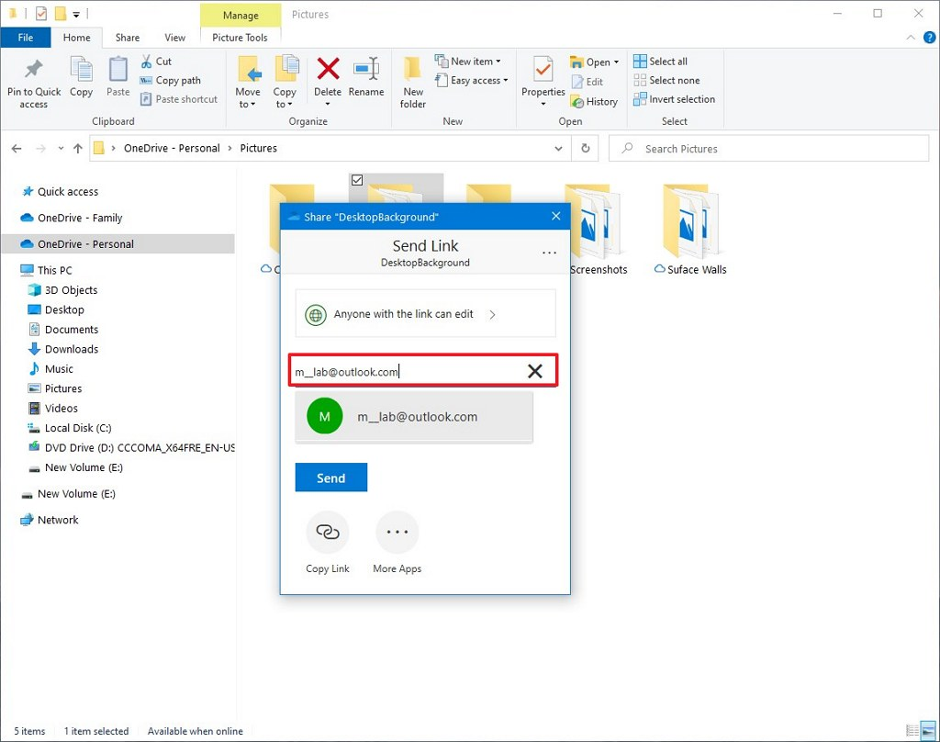

* Click the Send button.

1. **Sharing OneDrive files from the web**

* Open OneDrive online.
* Navigate to the file or folder you want to share.
* Right-click the item and select the Share option.



* Specify the email for the person you want to share the content. (Or the available options to copy the link.

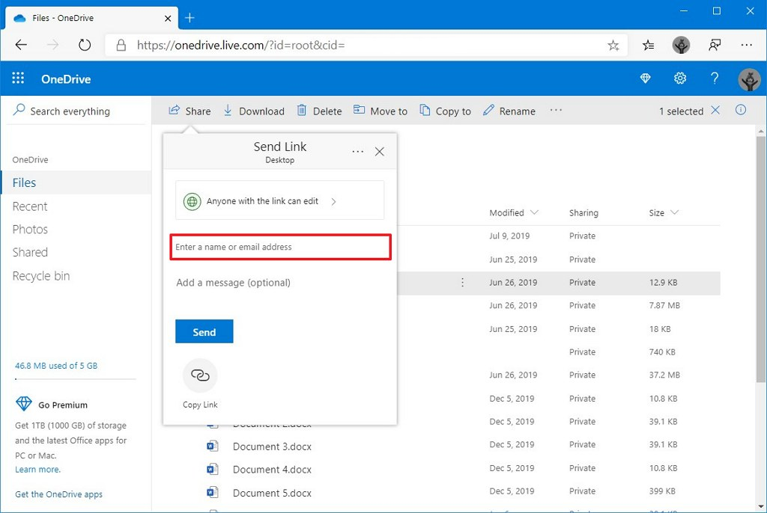

* Click the Send button.

**Conclusion: In this experiment we learnt to share files within the same network.**